http://jakartaglobe.id/news/indonesia-italy-bilateral-relations-focus-creative-economy/
By Sheany February 08, 2018
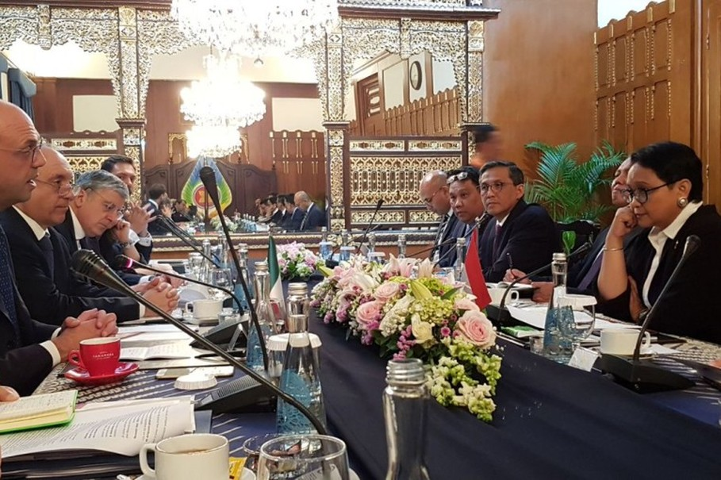

Indonesia-Italy Bilateral Relations to Focus on Creative Economy
Indonesia and Italy agreed to strengthen bilateral cooperation in creative economy during a meeting between their foreign ministers in Jakarta on Wednesday (07/02). (Photo courtesy of the Italian Foreign Affairs Ministry)
Jakarta. Indonesia and Italy made an agreement to strengthen bilateral cooperation in creative economy — seeking to seize opportunities in both countries — during a meeting between their foreign ministers in Jakarta on Wednesday (07/02).
"Creative economy is a field both countries have strengths in, so we've agreed to strengthen our economic cooperation there," Indonesia's foreign minister Retno Marsudi said.
In 2019, Indonesia and Italy will celebrate the 70th anniversary of their diplomatic relations. Retno and her Italian counterpart, Angelino Alfano, have agreed on a creative economy theme for the commemorations, with a special focus on small and medium enterprises.
The cooperation may involve various industries, including food, fashion and furniture.
"After this meeting, there will be an exchange of delegations to identify the sort of cooperation that we can do in the future. We will also try to conclude negotiations on the draft agreement for cooperation in creative economy," Retno said.
Italy is Indonesia’s third largest trade partner in the European Union. As of November 2017, Indonesia-Italy bilateral trade was worth more than $3 billion, up around 16 percent from a year before.
"We are very much aware of the opportunities in Indonesia to forge partnerships in energy, city planning, logistics, maritime and defense," Alfano said.
He added that many Italian companies are ready to provide skills in technology on fields that are relevant to Indonesia.
Both ministers also touched on ongoing interfaith dialogue between the two countries, which they deemed as instrumental to forge respect and to counter intolerance and radicalization.
Alfano said Italy regards Indonesia as key in its cooperation with the Association of Southeast Asian Nations (Asean).
After Jakarta, Alfano will continue his trip to Singapore and Thailand. In Bangkok, he is scheduled to meet Thai Prime Minister Prayuth Chan-ocha.

