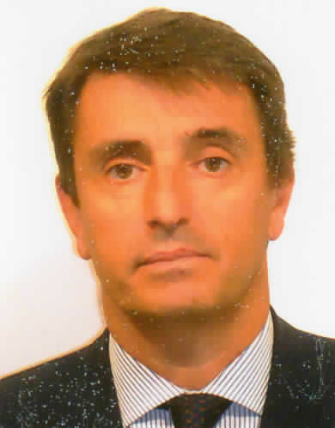

Minister Plenipotentiary
Alessandro CORTESE

Born in Rome on 16 October 1960, graduated in Law at the University of Rome (“La Sapienza”) in 1984, he attended the training course of the Diplomatic Institute of the Ministry of Foreign Affairs (MFA) from October 1984 and entered the Diplomatic Service in March 1986.
He served at the Secretariat of the Development Aid Department of the MFA and then assigned to the General Secretariat in 1988. He was posted to South Africa from October 1989 to March 1993 as economic and commercial Counsellor of the Italian Embassy in Pretoria.
Seconded from March 1993 to the General Secretariat of the Council of the European Union in Brussels, he worked at the European Political Cooperation, then Common Foreign and Security Policy (CFSP) Directorate (Head of the CSCE/OSCE – Council of Europe desk, dealing also with the “Stability Pact for South-Eastern Europe”). He is then assigned in 1995 to the Italian Permanent Representation to the EU as CFSP Counsellor (Chairman of the EU CFSP Counsellors working group and co-Chairman of the former-Yugoslavia working group during the Italian EU Presidency in 1996).
From October 1997 to November 1999, he is Head of one of the three desks of the Press Department of the MFA, dealing with Italian and foreign media and responsible for the web site and the technological improvements of the Department.
Seconded to the General Secretariat of the EU Council in Brussels from November 1999 to July 2002, as Head of the Western Balkans Unit. Deputy Ambassador at the Italian Embassy in Ottawa from July 2002 until July 2006, he is later assigned to the Ministry Press Service as Deputy Head.
In May 2008, he is appointed Diplomatic Advisor of the President of the Chamber of Deputies of the Italian Parliament, after which he is posted in July 2012 to Brussels as Permanent Representative to the Political and Security Committee of the EU. Back to Rome early 2017, he has been serving as Coordinator for the Italian 2018 OSCE Chairmanship.
From December 2017 to 21st of June 2018, he is Deputy Director General for Political Affairs and Central Director for Security.

He is currently Head of the Service for Press and Institutional Communication.
He is married and he has a son.

