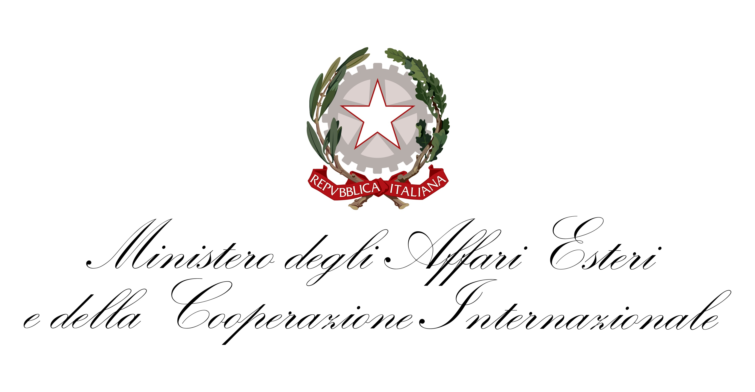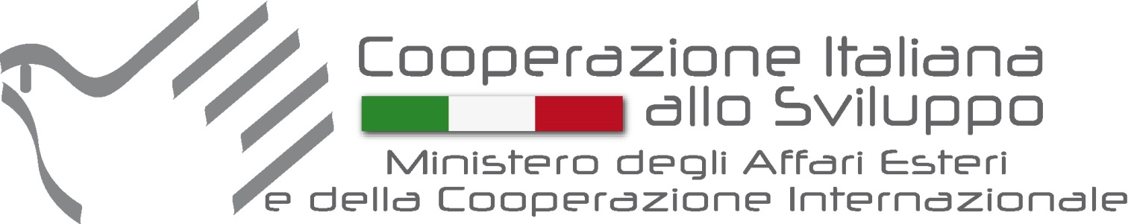

In collaboration with the International Organizations based in Italy

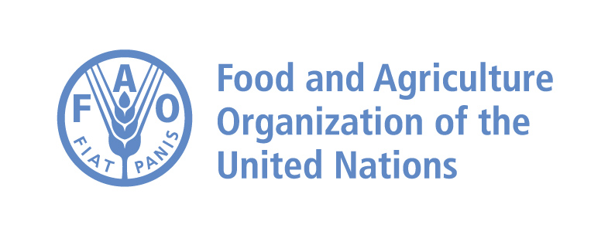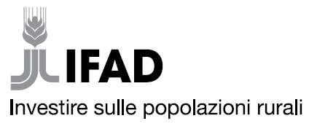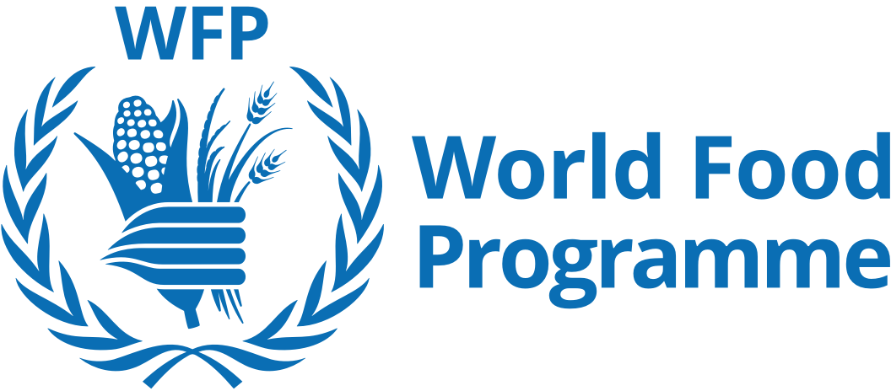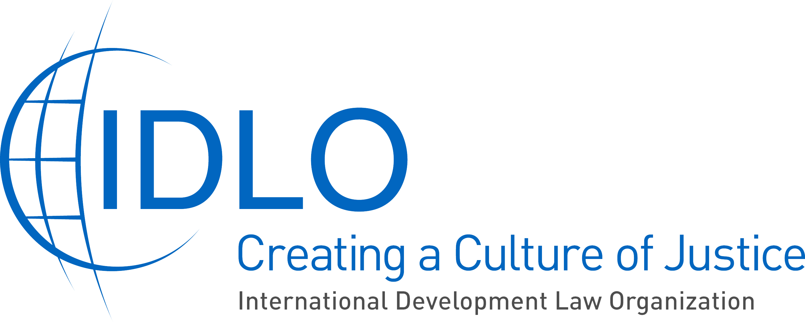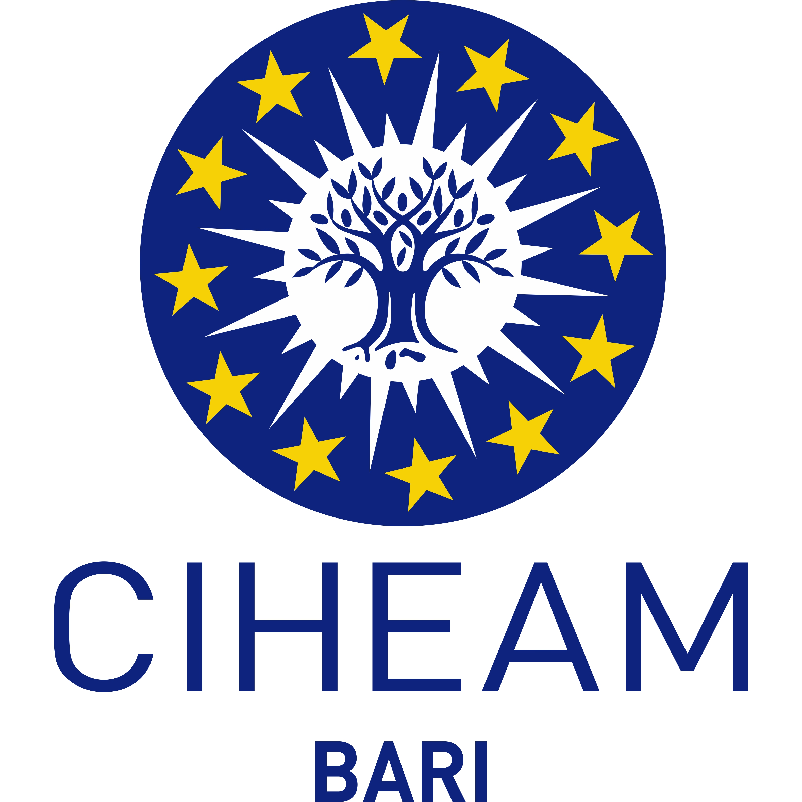

WORLD FOOD DAY 2018
The value of tradition: managing innovation without waste
Local productions to promote health, environment protection, incomes and sustainable development
12 October 2018, Italian Ministry of Foreign Affairs and International Cooperation, International Conference Hall)
MAECI – Rome

9.00 – 9.30 | REGISTRATION
9.30 – 10.30 | INSTITUTIONAL SESSION  - SPOT and VIDEO FAO for WFD2018  - 9.30: Opening remarks: Emanuela DEL RE, Vice Minister in charge of Cooperation/Ministry of Foreign Affairs and International Cooperation  - 9.35: Overview of the projects of Italian Cooperation: Luca MAESTRIPIERI, Deputy Director-General of Development Cooperation  - 9.40: Speeches of the Heads of the International Organizations based in Rome:  - Daniel GUSTAFSON, Deputy Director-General, FAO  - Cornelia RICHTER, Vice President, IFAD  - Amir Mahmoud ABDULLA, Deputy Executive Director, WFP  - Anne M. TUTWILER, Director-General, Bioversity International  - Maurizio RAELI, Director-General, CIHEAM Bari
10.30 – 11.00 | CULTURAL BREAK with songs from Piazza Vittorio’s Orchestra
10.30 – 11.00 ROUND TABLES – Moderator: Andrea SEGRE’ (University of Bologna/Last Minute Market)
Sess. 1 | - The role of traditional knowledge and agricultural biodiversity in sustainable development: Daniele DONATI (FAO), Elisabetta MORO (Università "Suor Orsola Benincasa" Napoli), Isabella DALLA RAGIONE (Fondazione Arborea), Gabriella CINELLI (ArcheoChef).
Sess.2 | - The role of healthy and local diets, including the Mediterranean diet, in nutrition and health, with a special focus on the work of the Italian working group for the implementation of the UN Decade of Action on Nutrition: Giuseppe RUOCCO (Segretario Generale del Ministero della Salute), Marcello De Vito (Presidente dell'Assemblea Capitolina), Laura BALDASSARRE (Assessora alla persona, alla scuola e alla comunità solidale di Roma Capitale), Pietro Antonio MIGLIACCIO (Presidente Onorario della Società Italiana di Scienza dell’Alimentazione - S.I.S.A.).
Sess. 3 | - The role of quality products and the protection of the environment. Sustainable development, with specific regard to nutrition, culture and tourism: Grammenos MASTROJENI (DGCS), Paolo GALLI (Centro di Ricerca e Formazione dell'Università di Milano-Bicocca - Maldive), Pierluigi MONTALBANO (Università La Sapienza di Roma), Duccio CACCIONI (Fondazione FICO).
12.40 – 12.50 | THE EXPERIENCE OF ITALIAN COOPERATION  The experience of Italian Cooperation in the field of food safety and sustainable rural development: Leonardo CARMENATI, Vice Direttore dell’Agenzia Italiana per la Cooperazione allo Sviluppo/AICS

12.50 – 13.10 | CONCLUSION  Emanuela DEL RE, Vice Minister in charge of Cooperation, Ministry of Foreign Affairs and International Cooperation.

13.20 | FOOD AS ART AND CULTURE  - In the kitchen for the environment: Carlo CRACCO  - Giobbe COVATTA, Campagna Spreco Zero’s Testimonial 2018/2019  - Comics exhibition “Primo non sprecare, secondo Altan. Lo spreco formato vignetta”.

