Minister Plenipotentiary Giovanni Pugliese
Head of Press Department and Institutional Communication
Curriculum Vitae

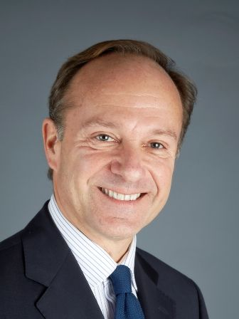

Born on July 5th, 1962

Education

1987 Master in Political Sciences - University of Rome

Work experience

October 2019 Head of Press Department and Institutional Communication

2018 – 2019 Diplomatic Advisor to the Minister of Economic Development, of Labour and Social Policies

2015-2018 Deputy Permanent Representative of Italy to the European Union – COREPER I Ambassador - Brussels

2011-2015 Deputy Head of Mission at the Italian Embassy Berlin

2009-2011 Director for Disarmament, Arms Control and non-
Proliferation - Foreign Ministry - Rome

2006-2009 First Counsellor at the Permanent Mission of Italy to the
UN - New York

2002-2006 First Counsellor at the Permanent Mission of Italy to the
European Union - Brussels

1998-2002 Counsellor at the UN Desk - Foreign Ministry -
Directorate General for Political Affairs - Rome

1994-1998 First Secretary at the Permanent Mission of Italy to the
International Organizations - Geneva

1991-1994 First Secretary at the Italian Embassy in Beijing - China

1988-1990 Second Secretary at the NATO Desk - Foreign Ministry -
Directorate General for Political Affairs - Rome

