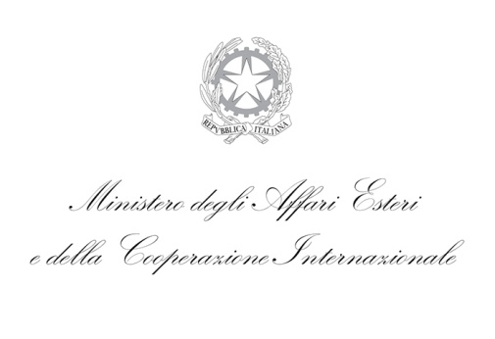
APPLICATION FORM
Expression of Interest short proposal
Call 2019 – 2021

1.1 Acronym
(Do not exceed 20 characters)

1.2 Title | (Do not exceed 120 characters)
1.3 Summary | (Do not exceed 240 characters)
1.4 Research Area  (please choose only one) | - Artificial Intelligence (Brain-inspired Artificial Intelligence, Intelligent City)  - Technologies related to astrophysics  - Innovative biomedical devices (medical robots, tissue engineering, new therapeutics, neurodegenerative diseases and personalized medicine)  - Innovative processes for biomass conversion into energy and other added value products

2. Project Outline
2.1 Objectives and Targets of the Project (max 5000 chars)
2.2 Innovative Points (max 1000 chars)

2.3 Technical line and Research foundation (max 2000 chars)

2.4 List of participants from the two sides (max 1000 chars)

Please, send a copy of the short proposal, duly signed by the Italian PI, by certified e-mail to dgsp09.pec@cert.esteri.it

