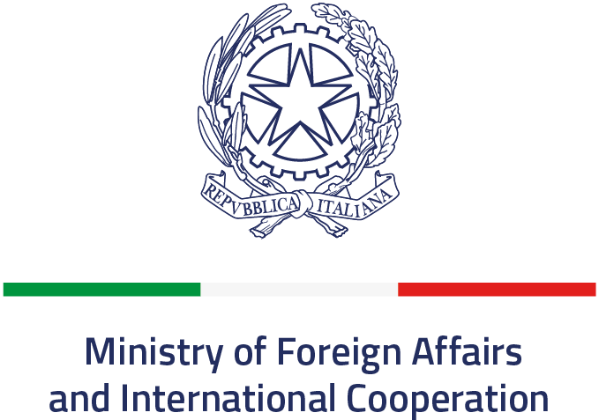



MINISTRY OF FOREIGN AFFAIRS
MINISTRY OF SCIENCE AND
TECHNOLOGY
STATE OF ISRAEL

AND INTERNATIONAL COOPERATION
DIRECTORATE GENERAL FOR CULTURAL AND
ECONOMIC PROMOTION AND INNOVATION
Italian REPUBLIC

APPLICATION Form

Area of Cooperation | Acronym | Italian Organisation Name | Italian Principal Investigator | Israeli Organisation Name | Israeli Principal Investigator

To be filled in English:
1.1
Project proposal
Title in English
(max: 120 characters)

Acronym

Key-words (5): in English
Italian Institution submitting the proposal
(University, Research Organism, other: specify):
(public/private: specify)
Official name:
Address (street, post code and city):
Telephone |  | Fax:
E-mail:
Italian Principal Investigator
Surname, Name:
Qualification:
Telephone: |  | Fax:
Contact address (street, post code and city):
E-mail:
Israeli partner Institution
(University, Research body, other: specify):
(public/private: specify):
Official name:
Address (Street, post code, city):
Telephone: |  | Fax:
E-mail:
Israeli Principal Investigator
Surname, name:
Position:
I.D. No. (in full):
Telephone: |  | Fax:
Contact Address (Street, post code, city):
E-mail:

Institutional Authorization
Important: The submitted copies should include one form with the original signatures of the submitting Principal Investigators and corresponding authorizing officials from their institutions.

Signature of the Italian Authorizing Official;

First Name : ________________________ Last Name: ________________

Position: ___________________________

Date: _____________________________ Signature: _________________________

Signature of the Israeli Authorizing Official;

First Name : ________________________ Last Name: ________________

Position: ___________________________

Date: _____________________________ Signature: _________________________

Signature

of the Italian Principal Investigator

Signature

of the Israeli Principal Investigator

1.2

Budget Summary
 | Total Italian Budget (in EURO ) | Total Israeli Budget (in EURO)
First year*
Second year*
TOTAL (2 years)
TOTAL (Italian +Israeli)
* Please attach a Gantt chart describing each phase of the project

1.3 Composition and description
of the Italian research unit involved in the Project
NAME | POSITION | FUNCTION

1.4 Italian scientific co-ordinator’s CV

(max: 20 lines including 5 bibliographical references)

1.5
Composition and description
of the Israeli research unit involved in the Project
NAME | POSITION | FUNCTION

1.6

Israeli scientific co-ordinator’s cv
(max: 20 lines including 5 bibliographical references)

Abstract

- The abstract should not exceed 500 words and should present:
- Objectives
- Methodology
- Potential scientific contribution of the proposed research
- Mode of cooperation and added value

Abstract:

scientific justification and workplan

B. This section should describe the background and the proposed research. The mode of cooperation between the Italian and Israeli groups should be evident, and the added value provided by the collaboration

The project description should include:

- Detailed description of the research topic, involving the state of the art in the research field and discussion of the scientific and technological background of each element of the project.
- Expected impact of the project in all relevant aspects (e.g., scientific, social, economic).
- Detailed research program, including specific goals, methodology and work plan. Key scientific issues should be emphasized. The roles of Italian and Israeli partners in carrying out the proposed research plan should be indicated, and the mode of integrating the work of the teams should be described.
- Description of available resources, including short CV of team members and inventory of relevant equipment.
- Description of previous joint cooperation between the two PIs, if any (5 lines)
- Compatibility of the proposed research with this call for proposals (5 lines)
- Bibliography of relevant literature.

Please number the sections of the project description according to the numbers in the list above.
Items 1 through 3 are limited to a total of 5 pages, font 12, single space, regular margins.

PREVENTIVO DI SPESA per 2 anni
TRACK SCIENTIFICO ANNO 2021
N.B. Si prega di esprimere le cifre secondo il seguente esempio: € 100.000,00

a) Costi di personale
Cognome e Nome | Qualifica | Tipologia contrattuale Es.: contratto di lavoro a tempo determinato/ indeterminato/ assegno di ricerca/borsa di studio, dottorato, dottorando, etc. | Costo orario | N° ore | Costo totale  (da CCNL applicato- ove applicabile)
 |  |  |  |  | €
Totale a) |  | €

b) Viaggi da e per Israele
Nominativo | Percorso | Costo
 |  | €
 |  | €
 |  | €
Totale b) | €

c) Materiale di laboratorio/attrezzature/strumenti (max 30% del costo complessivo del progetto)
Descrizione | Costo
Elettronica: | €
Meccanica: | €
Etc… | €
Totale c) | €

d) Spese generali di Amministrazione (max 8% del budget totale) *
Descrizione | Costo
Spese notarili per costituzione Consorzio/ATI/ATS | €
Totale e) | €

e) Totale costi del progetto a)+b)+c)+d) = budget della parte italiana indicato nell’Application Form al punto 1.2. Il finanziamento concesso potrà arrivare fino ad un massimo del 50% di tali costi. | €
* i costi indiretti possono essere forfettariamente rendicontati e calcolati percentualmente, con l’applicazione di un’aliquota massima pari al 3% del costo del progetto (e).

Firma del Responsabile Amministrativo

