|  |  |  |
| --- | --- | --- |
|  |  |  |

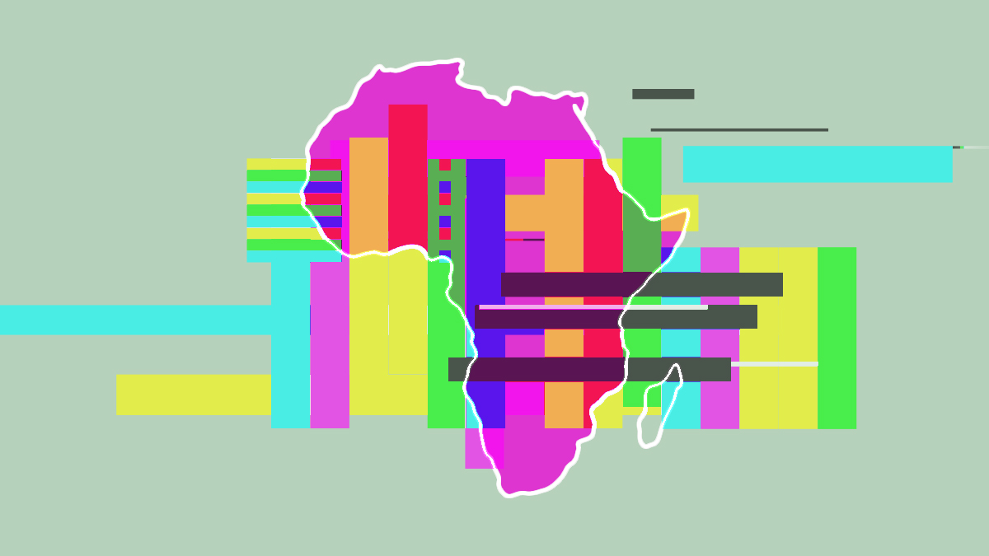

**Strengthening local digital ecosystems in Africa**

***Industry, Innovation, Infrastructure and Financing for Sustainable Development***

**Workshop**

*10AM – 2.30 PM, October 20th 2023*

***Location: Ministry of Foreign Affairs and International Cooperation, Rome Sala Aldo Moro***

**[REGISTER HERE FOR IN PERSON ATTENDANCE](https://docs.google.com/forms/u/2/d/e/1FAIpQLSdQyfqxU4aPjEp1OS8z81-D_6hcC8lTN65MKev0t3lvwqTvcg/viewform?usp=send_form)**

**Summary**

The **Italian Ministry of Foreign Affairs and International Cooperation, THE Italian Agency for Development Cooperation** and the **United Nations Development Programme (UNDP)** will co-host a workshop in Rome, Italy on the 20th of October 2023 about “Digital for Development “.

The objective of the day is to bring together diverse perspectives in view of understanding the unique opportunities for the private sector in the African continent and ultimately inform possible “digital for development” priorities of the Italian Digital for Development Strategy, also in the perspective of the upcoming G7 Presidency in 2024. The workshop will be divided into two main session blocks.

1. **Morning Session held in hybrid format (in presence and virtual) and with Italian/English simultaneous translation: Role of the private sector in the digital transformation to enhance green and inclusive growth and development, with a specific focus on Africa.**

* Convene private sector representatives (business associations and interested companies both from Italy and Africa) to reflect on the challenges and opportunities of investing and partnering for inclusive and green digital transformation in Africa, strengthening local digital ecosystems. The audience will also include stakeholders from International Organisations (IOs), Civil Society Organisations (CSO) and the Italian MFA and Italian Cooperation Practitioners. These will gather insights on the needs highlighted by the private sector participants to develop recommendations for collective action and global leadership to foster a rights-based inclusive and green digital transformation. These inputs will feed directly into the policy discussion in the afternoon.

1. **Afternoon Session (with selected participation and with English only as working language): Toward a global policy fit for a rights-based, human centric, inclusive and green “digital for development” and the road to the Italian 2024 G7 Presidency**

* The conversation will continue with 10-15 global and regional organizations, Italian government officials and experts: Italian MFA, AICS (Italian Agency fro Development Cooperation), CDP (acts as Italian Development bank), DTD (Department of Digital Transformation), AGID (Agency for a Digital Italy) etc. and major Civil Society Organizations to reflect on the possible outlines of a Digital Strategy of Italian Cooperation in view of the future planning of an Italian action for development. On a general and global policy level, possible governance gaps will be examined and possible priorities of the Digital Agenda of the future Italian G7 Presidency in 2024 will be discussed.

The key findings of the two sessions’ discussion will be synthetized in a food-for-thought paper, which will be submitted to the Italy-Africa Summit, a governmental meeting of Italian and African leaders’ due to take place in Rome on November 5-6.

**Context: G7 & Digital Development**

The next era of development will be defined by how efficiently and sustainably countries can leverage the immense power of digitalization. These technologies will be central to driving progress across all Sustainable Development Goals (SDGs) -from advancing decisive climate action to spurring new efforts to restore our natural world-creating millions of new opportunities and driving forward human development.

However, digital technologies require stewardship, governance and capacities to ensure people-centricity and safeguards. Closing the “digital divide” advancing “just green transitions” in developing countries through a strong focus on “Digital for Development” is critical in the face of emerging challenges. Focusing on Africa, with 60% of the population below 25 years old, private sector partnerships can significantly accelerate inclusive and sustainable digital development, creating new opportunities for local digital ecosystems. However digital development is context specific, with varying levels of development; geographical disadvantages and advantages; projected impact of climate change (resilient vs vulnerable); and political stability.

*Looking towards the Italian Presidency of the 2024 G7:* The work of the Indian G20 Presidency on Digital Public Infrastructure and closing the digital gap, the G7 Partnership for Global Infrastructure and Investment (PGII), EU-led initiatives such as the EU Global Gateway and the Digital-4-Development Hub, as well as Italy’s vision sketched out in the “Piano Mattei” look at digital transformation as a powerful tool to advance the 2030 Agenda.

The Italian Ministry for International Affairs and International Cooperation, the Italian Agency for Development Cooperation and UNDP will co-host a workshop to reflect on the role of (and opportunities for) the private sector in digital transformation, with a priority focus on the African continent. The workshop will also reflect on the outlines of an Italian ‘digital strategy for development’ in view of a future planning of the Italian action for development. It will also be possible to discuss the strategic priorities and concrete results for the Italian Digital Agenda for Development, considering the upcoming Italian G7 Presidency.

**Objectives & Agenda of the Workshop**

The workshop will convene (in presence) up to 80 stakeholders, both from public and private sector, to generate a discussion on the specific needs to enhance the role of the Italian and African private sector in “digital for development” and to inform the Italian Digital for Development agenda in this area.

*Objectives:*

* Present the latest trends and good practices/examples on the role of the private sector in local digital ecosystems to advance sustainable and inclusive digital transformation.
* Engage in constructive discussions with business association representatives, Italian and African companies, leaders and practitioners from Africa and experts in the field of digital transformation to provide insights into potential areas where Italy could enhance the participation of the private sector, including during the upcoming Italian G7 Presidency in 2024.
* Draft a set of possible policy deliverables that could inform Italy’s global leadership in enhancing its own “digital for development” strategy.

*Target participants:* Officials from the Government of Italy, the Italian Cooperation System, the European Union, UNDP and other UN experts, Civil Society Organisations, Business association representatives, companies, financial institutions and key strategic partners about current trends in digital agenda across all Sustainable Development Goals (SDGs).

**Agenda:**

|  |  |
| --- | --- |
| 10 – 10:30 | Breakfast Reception |
| Morning Session: Role of the private sector in the digital transformation to enhance growth and development | |
| 10:30 – 10:45 | **Session 1: Introductory remarks** |
| 10:45 – 11:15 | **Session 2: Framing Digital Development for the Sustainable Development Goals** |
| 11:15 – 11:45 | **Session 3: Panel Discussion: Opportunities to Close the Digital Divide & Advance Green/Digital Transitions in Africa – The Role of the Private Sector** |
| 11:45 – 12:00 | **Session 4: Demonstration of Private Sector Partnerships for Impact & Scale** |
| 12:15 – 1:00 | **Session 5: Panel Discussion: Closing the Financing Gap for Digital Transformation & Digital Infrastructure** |
| 1:00 – 1:15 | **Session 6: Summary of the Key Points & Closing of Morning Session** |
| 1:15 – 2:30 | **Lunch Break** |