**TUBITAK 2236-A Co-Funded Brain Circulation Scheme3 (CoCirculation3) – 2025 Call for Applications Published**

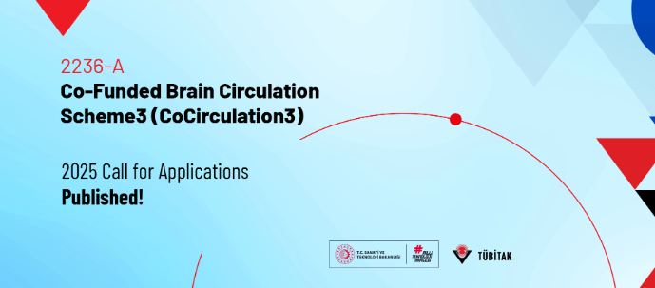

**Dear Researchers, Research Performing Institutions,**

The 2025 call of [TUBITAK 2236-A Program](https://tubitak.gov.tr/en/scholarships/doktora-sonrasi/arastirma-burs-programlari/2236a-co-funded-brain-circulation-scheme3-cocirculation3) has been published by TUBITAK to support postdoctoral researchers in conducting research at leading institutions in Türkiye.

Funded under the European Commission’s MSCA [COFUND](https://ufukavrupa.org.tr/en/cluster-programs/marie-sklodowska-curie-actions/cofund) 2023 call, the [CoCirculation3 project aims to enhance Turkiye’s research and innovation ecosystem by attracting global talent.](https://ufukavrupa.org.tr/en/news/cocirculation3-project-submitted-under-horizon-europe-msca-cofund-call-has-been-awarded)

Researchers supported under the program (by TUBITAK) are expected to come from abroad and to carry out their projects for 24 months under the supervision of a host academic or non-academic institution in Türkiye. Additionally, the program offers an optional extension of up to 12 months in a non-academic organization.

🔹 The 2025 call will be open for applications between 1 September 2025 and 1 December 2025.  
🔹 Applications must be submitted online via TUBITAK Management Information System ([TYBS system](https://giris-tybs.tubitak.gov.tr/auth/realms/tybs/protocol/openid-connect/auth?client_id=tybs-frontend&redirect_uri=https%3A%2F%2Ftybs.tubitak.gov.tr%2F&state=03bf33cd-67ce-492a-841a-c7813e50272d&response_mode=fragment&response_type=code&scope=openid&nonce=67085f4d-c74e-4edd-92be-c67efe6be3d0))  
🔹 A total of 33 researchers will be funded in 2025.

**Scope of Support:**

The monthly support provided to researchers under the program is as follows:

* Monthly salary: €3,980
* Family allowance: €600
* Research, training, and networking support: €1,000
* Entrepreneurship allowance: €250
* Host institution share: €130 (Paid to the host institution.)
* Monthly travel allowance: €50 (up to €1,200 in total)

**Eligibility Criteria:**

* Open to all researchers (any nationality) holding a doctoral degree.
* Applicants must not have resided or carried out their main activity in Türkiye for more than 12 months within the past 36 months.
* Research proposals are expected to be aligned with the European Green Deal.

|  |  |  |
| --- | --- | --- |
| **Call Terms** | **Call Opening Date\*** | **Call Closing Date\*** |
| 2025 Call  (33 researchers to be funded) | 1 September 2025 | 1 December 2025 |
| 2026 Yılı Çağrısı  (33 researchers to be funded) | 3 August 2026 | 3 November 2026 |
| 2027 Yılı Çağrısı  (34 researchers to be funded) | 1 July 2027 | 1 October 2027 |
| **\***There might be slight changes in the opening and closing dates of the call. Please follow the programme’s official page for     the most up-to-date information. | | |

You can access detailed information and call documents on the [program website](https://tubitak.gov.tr/en/scholarships/doktora-sonrasi/arastirma-burs-programlari/2236a-co-funded-brain-circulation-scheme3-cocirculation3) and [cocirculation3.tubitak.gov.tr](https://cocirculation3.tubitak.gov.tr/)

Contact: cocirculation3@tubitak.gov.tr

(Please [click here](https://ufukavrupa.org.tr/en/news/22236-co-funded-brain-circulation-scheme3-cocirculation3-2025-call-applications-published) to access the original new.)

**Best regards,**

**Horizon Europe MSCA Türkiye Team**

**ncpmobility@tubitak.gov.tr**